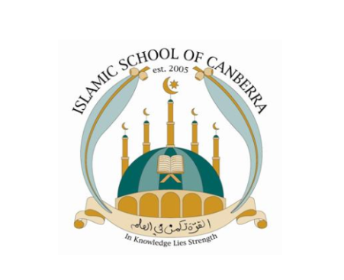

EXPRESSION OF INTEREST – Coordinator

The School Board and Principal invite applications for the role of Level 1 Coordinator at the Islamic School of Canberra. Initially, this position will be on a probationary basis for one term and additional duties with related pay rates will be according to the current EBA.

Duties will involve but not be limited to:

- Set up and assist in coordinating staffing, teacher timetabling and playground supervision
- Set up curriculum teams, identifying measurable goals as required
- Oversee the development and implementation of Individual Learning Plans
- Develop and implement the School’s Pastoral Care programme and student behaviour management processes
- Ensure that staff have adequate resources to deliver a differentiated curriculum
- Assist in administering NAPLAN and other external examinations as required.

Essential Criteria for the applicant:

- A minimum of 4 years teaching experience
- Proven high level skills within the classroom involving the development of resources, assessing and reporting
- High level of written and verbal communication skills
- Demonstrated skills in team building and resolving concerns and/or conflicts
- Experience working in a variety of different educational settings
- Ability to successfully work in a multi-faith, multicultural environment
- Demonstrate capacity to self-manage, self-reflect and evaluate policies and processes
- Effective communication with staff, students and parents/carers
- Experience in working with a variety of service providers/associations that support the social, emotional and/or academic development of students.
- High level of demonstrated skills in the use of ICT and related applications

Please forward your Application, marked CONFIDENTIAL and citing at least two referees, to: reception@isc.act.edu.au.

Applications CLOSE 4.00pm on 27 September 2019.
Please send your application to reception@isc.act.edu.au.

